A FIELD PROJECT REPORT

on

**“****BRAIN TUMOR DETECTION USING**

**MACHINE LEARNING TECHNIQUES”**

**Submitted**

**By**

221FA04268

D.Niharika

221FA04640

K.Mukesh

221FA04617

K.Yamini

221FA04719

J.Sravani

***Under the guidance of***

***MR.SOURAV MONDAL***

*Associate Professor*



**SCHOOL OF COMPUTING & INFORMATICS**

**DEPARTMENT OF COMPUTER SCIENCE & ENGINEERING**

**VIGNAN'S FOUNDATION FOR SCIENCE, TECHNOLOGY AND RESEARCH Deemed to be UNIVERSITY**

**Vadlamudi, Guntur.**

**ANDHRA PRADESH, INDIA, PIN-522213.**



**CERTIFICATE**

This is to certify that the Field Project entitled **“BRAIN TUMOR DETECTION USING MACHINE LEARNING TECHNIQUES”** that is being submitted by 221FA04268 (Niharika), 221FA04617(yamini), 221FA04640(Mukesh) and 221FA04719(Sravani) for partial fulfilment of Field Project is a bonafide work carried out under the supervision of MR.SOURAV MONDAL., Assistant Professor, Department of CSE.

Guide name& Signature  Designation HOD,CSE



**DECLARATION**

We hereby declare that the Field Project entitled “**BRAIN TUMOR DETECTION USING MACHINE LEARNING TECHNIQUES”** that is being submitted by 221FA04268 (Niharika),221FA04617(Yamini), 221FA04640(Mukesh) and 221FA04719(Sravani) in partial fulfilment of Field Project course work. This is our original work, and this project has not formed the basis for the award of any degree. We have worked under the supervision of MR.SOURAV MONDAL, Assistant Professor, Department of CSE.

By

**221FA04268 (Niharika),**

**221FA04617(Yamini),**

**221FA04640(Mukesh)**

**221FA04719(Sravani)**

## ABSTRACT

Machine learning-based brain tumor classification has become a vital medical imaging application that helps with early diagnosis and detection. A pre-trained ResNet50 model is used in this study to categorize brain MRI scans into four groups. To increase the model's capacity for generalization, the dataset is preprocessed using ImageDataGenerator, which incorporates a number of augmentation techniques like rotation, width and height shifts, shearing, zooming, and horizontal flipping. To ensure reliable model evaluation, the dataset is divided into subsets for testing, validation, and training.

The ResNet50 architecture serves as the foundation for the machine learning model; its top layers are eliminated, and custom fully connected layers are added to extract high-level features. Dense layers with ReLU activation are among the extra layers. dropout layers to lessen overfitting, followed by a final softmax layer to divide the photos into four groups. ResNet50's final ten layers are adjusted to maintain pertinent feature extraction capabilities while adjusting to the particular dataset. With a learning rate of 0.001 and momentum of 0.9, the stochastic gradient descent (SGD) optimizer is used to compile the model, guaranteeing smooth convergence.

Early stopping is used in the training process to avoid overfitting, and when validation performance reaches a plateau, Reduce LR On Plateau is used to dynamically modify the learning rate. A distinct subset of data is used for validation after the model has been trained for ten epochs.

Classification reports and confusion matrix analysis using Seaborn and Scikit-learn are part of the post-training evaluation. Through the visualization of misclassification patterns, the confusion matrix offers insights into the model's performance, while the classification For every category, the report displays important metrics like F1-score, precision, and recall. To verify the model's capacity for generalization, it is tested on the held-out test set.

The efficiency of transfer learning with ResNet50 for medical image classification is demonstrated in this work, which greatly increases accuracy while cutting down on training time. The findings imply that machine learning models can help doctors identify brain tumors more quickly. To improve classification accuracy even more, future research could examine other architectures like EfficientNet or Vision Transformers, hyperparameter tuning, and dataset expansion.

**TABLE OF CONTENTS**

1. Introduction 1
   1. Background and Significance of Brain Tumors 2
   2. Overview of Machine Learning in Medical Image Analysis 2
   3. Research Objectives and Scope 4
   4. Current Challenges in Brain Tumor Detection 5
   5. Applications of ML Brain Tumor Diagnosis 8
2. Literature Survey 12
   1. Literature review 13
   2. Motivation 17
3. Proposed System 18
   1. Input dataset 20

3.1.1Detailed features of dataset 20

* 1. Data Pre-processing 21
  2. Model Building 22
  3. Methodology of the system 24
  4. Model Evaluation 25
  5. Constraints 33
  6. Cost and Sustainability Impact 48

1. Implementation 51
   1. Environment Setup 52
   2. Sample code for preprocessing and CNN operations 52
2. Experimentation and Result Analysis 54
3. Conclusion 56
4. References 58

**LIST OF FIGURES**

|  |  |
| --- | --- |
| Figure 1. Architecture of the proposed Machine Learning Model | 24 |
| Figure 2. Data Pre-Processing and Feature Extraction | 24 |
| Figure 3. Training Vs Testing Accuracy | 26 |
| Figure 4. Confusion Matrix of the Model | 26 |
| Figure 5. Performance Metrics Comparison | 27 |
| Figure 6.  ROC Curve for Each Class | 28 |
| Figure 7. Confusion Matrix for Logistic Regression | 28 |
| Figure 8. Confusion Matrix for ANN | 29 |
| Figure 9. Confusion Matrix for KNN | 29 |
| Figure 10. Confusion Matrix For Random Forest | 30 |
| Figure 11. Confusion Matrix for XGBoost  Figure 12. Decision Tree Visualization | 30  31 |

**LIST OF TABLES**

Table 1. Dataset Distribution Across Training, Validation, and Testing Sets 30

Table 2. Data Augmentation Parameters Used in Preprocessing

Table 3**.** Model Architecture and Layer Details of ResNet50

Table 4. Training and Validation Accuracy/Loss Across Epochs

Table 5. Classification Report (Precision, Recall, F1-Score

**Table 6.** Confusion Matrix Values for Model Evaluation

# CHAPTER-1 INTRODUCTION

### INTRODUCTION

**1.1 Background and Significance of Brain Tumors**

Brain tumors are a serious medical condition that, if not identified and treated promptly, can result in serious neurological complications or even death. The analysis of MRI scans by radiologists is a major component of traditional diagnostic techniques, but it can be laborious and prone to human error. In order to get around these restrictions, medical image analysis has been using machine learning (ML) techniques more and more to automate and enhance the classification of brain tumors.

Tumor classification relies heavily on machine learning algorithms like Random Forest, XGBoost, Support Vector Machines (SVM), Logistic Regression, Naïve Bayes, and Multi-Layer Perceptron (MLP). These models extract important features like texture, intensity, and shape variations from preprocessed MRI datasets in order to learn from them. By determining the most pertinent tumor characteristics, feature engineering and selection also aid in increasing classification accuracy.

The objective is to create an effective system that can accurately differentiate between different tumor types by using machine learning (ML)-based classification models. Accuracy scores, ROC curves, and confusion matrices are examples of performance evaluation metrics that aid in determining how effective these models are. This research is important because it could improve early detection, lower diagnostic errors, and help medical professionals make quicker and more accurate decisions for patients with brain tumors.

Additionally, by combining several weak learners into a stronger classifier, ensemble learning techniques like Random Forest and XGBoost improve prediction accuracy. Traditional machine learning models are still useful because of their interpretability and lower computational requirements, but deep learning models, such as CNNs, have also been used extensively in medical imaging.

ML models are getting better at identifying and categorizing brain tumors as a result of the growing availability of sizable annotated medical datasets. However, methods like data augmentation, synthetic data generation (like SMOTE), and cross-validation are required to overcome issues like class imbalance, data scarcity, and overfitting.

Finally, by providing quicker, more affordable, and more precise tumor classification, ML-driven brain tumor detection holds the potential to completely transform medical diagnostics. Computer-aided diagnosis (CAD) systems, which can help radiologists with early intervention and individualized treatment planning, are made possible by these developments, greatly enhancing patient outcomes.

**1.2 Overview of Machine Learning in Medical Image Analysis**

One of the most serious and potentially fatal neurological disorders, brain tumors impact people all over the world. They can be divided into two categories: benign (non-cancerous) and malignant (cancerous). Because of their aggressive nature, malignant tumors pose a serious risk to one's health. Effective treatment planning, increased patient survival rates, and reduced neurological damage all depend on early and precise detection. Conventional diagnostic techniques, like MRI scans and biopsy operations, take a lot of time and might not always yield conclusive results. As a result, there is a growing need for intelligent and automated systems that can help with the diagnosis and classification of brain tumors.

Medical image analysis has advanced significantly since the introduction of machine learning (ML) and deep learning (DL) techniques. Large volumes of MRI data are used by ML models to find trends and accurately classify tumors. Convolutional Neural Networks (CNNs), ResNet, and VGG16 are examples of deep learning architectures that have shown impressive performance in image classification tasks, allowing for more accurate and effective brain tumor diagnosis.

A deep learning model based on ResNet50 has been used in this study to categorize brain tumors. To improve generalization and avoid overfitting, the dataset is augmented. For effective learning, Stochastic Gradient Descent (SGD) with momentum is used to train the model. Key evaluation metrics, such as ROC curves, accuracy scores, and the confusion matrix, are used to evaluate performance. Furthermore, analogies are evaluated for tumor classification efficacy using conventional machine learning classifiers like Logistic Regression, Naïve Bayes, Support Vector Machine (SVM), Random Forest, XGBoost, and Multi-Layer Perceptron (MLP).

This study shows how important deep learning is for detecting brain tumors early on, opening the door to better computer-aided diagnosis (CAD) systems in the medical field. Such AI-powered models can greatly help radiologists and other medical professionals make more precise and timely diagnoses with additional development and integration with the real world.

Additionally, by incorporating transfer learning strategies, models can take advantage of pre-trained architectures, which improves classification performance while lowering the requirement for large labeled datasets. In order to improve model interpretability and give medical professionals confidence in AI-driven decisions, explainable AI (XAI) techniques are also being investigated. Future studies seek to improve these models by adding multimodal data sources, like patient history and genetic data, for a more thorough tumor evaluation.

**1.3 Research Objectives and Scope**

The development of an effective and precise machine learning-based system for the detection and classification of brain tumors using MRI imaging data is the main goal of this study. The goal of this research is to analyze tumor characteristics and increase diagnostic accuracy by utilizing deep learning architectures and conventional machine learning classifiers. The following primary goals form the framework of the study:

**To create and put into use a deep learning model for classifying brain tumors:**

Make use of CNN-based architectures, such as ResNet50, and evaluate their performance against more conventional machine learning models, including **Random Forest, SVM, Logistic Regression, and Decision Trees.**

**To improve and preprocess MRI data in order to efficiently extract features:**

To increase model robustness, use strategies like **feature selection, data augmentation, and Histogram of Oriented Gradients (HOG).**

**To assess model performance with common metrics:**

To compare various machine learning techniques, evaluate classification accuracy, **confusion matrices, ROC curves, and F1 scores.**

**To solve issues with model interpretability and dataset constraints:**

**Use explainable AI (XAI)** and transfer learning strategies to increase generalization and dependability.

**Objectives and Scope of the Research:**

**objectives:**

**Create a Classification System Based on Machine Learning:** Use and contrast different machine learning algorithms for classifying brain tumors, such as Random Forest, SVM, Logistic Regression, and Decision Tree.

**Feature Extraction with HOG:** To improve model interpretability, use Histogram of Oriented Gradients (HOG) to extract discriminative features from brain tumor images.

**Performance Evaluation and Comparison:** Use confusion matrices and classification reports to evaluate the accuracy, precision, recall, and F1-score of various classifiers.

**Optimize Model Performance:** To decrease overfitting and increase classification accuracy, use feature scaling, selection, and hyperparameter tuning.

**Visual Representation of Model Results**: To show classification performance and feature importance, create confusion matrices and HOG feature visualizations.

**Scope:**

This study excludes other imaging modalities, such as CT scans, and concentrates on **MRI-based brain tumor detection.**

The study mainly uses supervised learning techniques to classify tumors into **binary and multi-class categories.**

To ensure a comprehensive assessment of various methodologies, the study incorporates comparisons between **deep learning models and traditional machine learning algorithms**.

The study's conclusions are meant to aid in the creation of **AI-powered medical diagnostic** instruments, which may find use in **computer-aided diagnosis (CAD) systems.**

In order to contribute to more effective and timely diagnosis solutions in medical imaging, the study intends to improve the accuracy, interpretability, and clinical applicability **of ML-based brain tumor detection systems.**

**1.4 Current Challenges in Brain Tumor Detection**

The Project of Brain Tumour Detection offers a strong pipeline for data preprocessing, feature extraction, model training, and evaluation in the context of machine learning (ML)-based brain tumor detection. Nonetheless, there are certain difficulties and places where the method could be strengthened to increase precision, effectiveness, and resilience. The following are some possible issues and enhancements to think about:

**1.Restricted Image Preprocessing and Augmentation :**

**Challenge:** The preprocessing that is currently in place primarily consists of HOG feature resizing. However, the model's performance may be impacted by the different resolutions, lighting, and noise that are frequently present in brain tumor images.

**Enhancement:**

**Data Augmentation:** To increase the model's resilience to various input conditions, incorporate data augmentation techniques like flips, rotations, zoom, and brightness changes.

**Image Normalization**: In addition to resizing, The model may become more stable during training if pixel values are normalized to a range of [0, 1].

**2.Problem with Class Imbalance:**

**Challenge:** Brain tumor datasets frequently have class imbalance, which causes biased model predictions because there may be a disproportionately high number of non-tumor images compared to tumor images.

**Enhancement:**

**Class Balancing:** Methods such as undersampling the majority class, class weighting during model training, or SMOTE (Synthetic Minority Over-sampling Technique) may be used to address class imbalance**.**

**Loss Function Modification:** The model may be able to concentrate on accurately identifying tumor images if the loss function is changed to penalize incorrectly classifying the minority class more severely.

**3.Challenge with Model Evaluation and Metrics:**

**Challenge:**Although accuracy is a valuable metric, it may not be the most accurate way to assess model performance, particularly when classes are unbalanced. Although classification reports and confusion matrices are useful, they don't always provide the whole picture, particularly in medical imaging where false negatives—or missed tumors—are crucial**.**

**Enhancement:**

**Measures like F1-Score, Precision, and Recall:** These would provide a clearer picture of how well the model is detecting tumors. When the distribution of classes is unbalanced, the F1-score is especially helpful.

The trade-off between the true positive rate and the false positive rate across various thresholds can be better understood with the help of ROC and AUC scores.

**4.Model Overfitting :**

**Challenge:** Conventional machine learning models, such as Random Forest and Decision Trees, are prone to overfitting, particularly in cases where the data is noisy or there are a lot of features.

**Enhancement:**

**Techniques for Regularization**: Use cross-validation to adjust hyperparameters, particularly for Decision Trees, or incorporate regularization techniques such as L2 regularization (Ridge) for logistic regression.

**Early Stopping:** When the model's performance on the validation set begins to deteriorate, early stopping can help prevent overfitting in deep learning models.

**5.Problem with the Validation Set:**

**Challenge:**Although the current code divides data into training, testing, and validation sets, it's unclear if the validation set is used for hyperparameter tuning during training**.**

**Enhancement:**

**Cross-Validation:** To maximize the use of the available data and minimize variance in the performance metrics, employ k-fold cross-validation during training.

**Hyperparameter tuning:** To maximize models such as SVM, Random Forest, and others, use a grid search or random search.

**6.Interpretability :**

**Challenge:** A major issue in medical applications is the inability of neural networks, especially deep learning models, to be easily interpreted.

**Enhancement:**

To make sure the model's decisions are understandable in medical applications, it is essential to use tools like SHAP (SHapley Additive exPlanations) or LIME (Local Interpretable Model-agnostic Explanations) to comprehend model predictions.

**7. Model Generalization**

**Challenge:** When medical imaging data comes from various sources or imaging modalities (such as MRI vs. CT scans), a model trained on one dataset may not generalize well to unseen data.

**Enhancement:**

**Domain Adaptation:** Use strategies like transfer learning on various datasets to increase the model's flexibility to various imaging sources or conditions.

**8.Computational Complexity**

**Challenge:** Especially for large datasets, training models on high-resolution medical images can be costly and time-consuming.

**Enhancement:**

**Hardware Optimization:** To speed up deep learning model training, make use of GPUs or cloud computing platforms.

**Model Efficiency:** Take into account employing lighter models, such as MobileNets or EfficientNet, which are made to infer information more quickly without sacrificing performance.

**1.5 Applications of ML Brain Tumor Diagnosis**

Machine learning (ML) for brain tumor diagnosis has transformed medicine by making it possible to identify tumors from MRI images more quickly and accurately. This model turns MRI images into numerical data using Histogram of Oriented Gradients (HOG) feature extraction. Several classifiers, such as Random Forest, Support Vector Machine (SVM), Logistic Regression, and Decision Tree, then analyze the data. By differentiating between healthy and tumor-affected brain tissues, these classifiers lessen the possibility of human error in manual diagnosis.

Early brain tumor screening and detection is one of the model's most important uses. Improving survival rates requires early diagnosis, and ML-powered systemscan assist in detecting tumors before symptoms worsen. Research facilities and hospitals can Use these models for extensive screenings to guarantee that patients who are at risk receive prompt medical attention.

Furthermore, radiologists can use this ML-based method as a decision-support tool. As a second opinion to confirm human diagnoses, the model offers an unbiased evaluation of MRI scans. This tool helps radiologists concentrate on more complex cases and improves the accuracy of medical assessments by lowering subjectivity in tumor classification.

Personalized treatment planning is another important application. This model assists oncologists in selecting the most appropriate treatment, such as radiation therapy, chemotherapy, or surgery, by categorizing tumor types and severity levels. Precision medicine is made possible by this AI-powered analysis, which allows doctors to customize treatments for each patient according to the features of their tumors.

Beyond clinical settings, ML-based tumor detection is essential for medical education and research. These models can be used by researchers to examine sizable brain scan datasets and spot trends and patterns in the growth of tumors. AI-assisted diagnosis tools can also be used by radiology trainees and medical students to enhance their learning of tumor classification methods.

Finally, by automating tumor detection and reducing the need for thorough manual analysis. Hospitals can save time and money by expediting the diagnostic process, which will increase the affordability and accessibility of healthcare services. All things considered, machine learning is revolutionizing the diagnosis of brain tumors by offering quicker, more precise, and more effective answers to one of the most pressing problems in medical imaging.

**Applications:**

**Enhanced Diagnostic Speed**: By automating tumor detection, the model cuts down on the amount of time needed for manual analysis.

**Decrease in Human Error:** AI-based categorization reduces diagnostic subjectivity and variability.

**Scalability:** Capable of being implemented in numerous clinics and hospitals to effectively analyze high volumes of MRI scans.

**Non-Invasive Diagnosis:** This method analyzes MRI scans digitally without the need for more invasive techniques.

**Multimodal Imaging Support:** This feature can be expanded to analyze additional medical imaging modalities, such as PET and CT scans.

**AI-Powered Tumor Progression Monitoring**: Assists in tracking the growth of tumors over time to improve treatment modifications.

**Integration with Cloud-Based Healthcare Systems:** This feature can be used to enable real-time and remote diagnosis on cloud platforms.

**Possibility of Multi-Class Tumor Classification:** The model can be extended to distinguish between various kinds of brain tumors.

**Modifiable for Additional Medical Imaging Tasks:** The feature extraction and classification methodology can be modified to address additional illnesses like Alzheimer's disease, diabetic retinopathy, and lung cancer.

# CHAPTER-2 LITERATURE SURVEY

## LITERATURE SURVEY

#### Literature review

The early detection of serious illnesses like brain tumors depends heavily on medical image analysis. Conventional radiological examination techniques depend on subjective and time-consuming manual interpretation. Machine learning (ML) techniques have been widely used for automated brain tumor classification in order to overcome these constraints. Classical machine learning models with handcrafted features are still a viable alternative because of their interpretability and lower computational requirements, even though deep learning models like Convolutional Neural Networks (CNNs) dominate the field[1].

In ML-based brain tumor classification, feature extraction is crucial. Classical machine learning techniques rely on manually designed feature extraction methods like the Histogram of Oriented Gradients (HOG), in contrast to deep learning, which learns features automatically. HOG is frequently used to record texture and edge information that separates tumorous from non-tumorous areas. According to research, classification performance is greatly enhanced when HOG is integrated with ML classifiers.[2].

Originally created for object detection, HOG has many uses in medical imaging. It is especially helpful for detecting brain tumors because it extracts gradient-based features that draw attention to important image structures. Numerous studies attest to the fact that HOG in conjunction with ML models yields results that are on par with deep learning techniques while requiring less computing power.[3].

In the classification of brain tumors, traditional machine learning models such as Support Vector Machines (SVM), Random Forest (RF), Logistic Regression (LR), and Decision Trees (DT) have shown great promise. These models work especially well when combined with reliable feature extraction methods.

SVM: A popular classification technique, SVM is renowned for its resilience in high-dimensional spaces. High accuracy is attained by linear and kernel-based SVMs, according to studies, especially when paired with feature selection methods like SelectKBest.

In medical imaging applications, RF—an ensemble learning technique that combines several decision trees—has demonstrated exceptional classification performance, handling high-dimensional datasets with ease.

LR: LR is a powerful baseline classifier even though it is a simpler model. LR has proven to be competitively accurate when applied to specific features in binary classification tasks like as the identification of tumors.

DT: Although they are prone to overfitting, DT classifiers are straightforward but efficient, particularly when feature selection strategies are used to reduce superfluous complexity.[4].

For ML performance to be optimized, preprocessing is essential. Model performance is guaranteed by methods like feature scaling and selection. SelectKBest is used to extract the most informative features, improving classification performance and lowering computational complexity, while StandardScaler is frequently used to normalize feature distributions.[5].

When evaluating machine learning models, performance metrics like accuracy, precision, recall, F1-score, and confusion matrices are crucial. When combined with handcrafted features like HOG, SVMs achieve competitive accuracy rates while maintaining computational efficiency, according to studies comparing CNNs and classical ML models.[6].

Because of their efficiency and interpretability, classical machine learning models are still used in medical image analysis. Classical methods offer workable solutions for resource-constrained environments, in contrast to deep learning models, which demand large labeled datasets and significant processing power.[7].

Notwithstanding their benefits, machine learning models have a number of drawbacks, such as the difficulty of feature selection, interpretability issues, and the requirement for a variety of training datasets. Careful optimization and validation are needed to address these issues.[8].

Medical image analysis presents a number of difficulties for ML models, despite encouraging outcomes:

**Feature Engineering Complexity:** It takes a lot of trial and error to find the most informative features.

**Data Imbalance:** Biased model performance results from the majority of medical imaging datasets having more non-tumor samples than tumor samples.

**Model Interpretability:** Although feature engineering is still a bottleneck, classical machine learning models are easier to understand than deep learning models.

**Limited Annotated Data:** The efficiency and generalization of model training are limited by the lack of large labeled samples in many datasets..[9].

With numerous opportunities for study and advancement, machine learning-based brain tumor detection has a bright future. Combining MRI with other imaging modalities like PET or CT scans is one possible approach to multimodal data integration. This method might increase classification accuracy and offer a more thorough picture of the tumor. [10]

Brain tumor detection has seen encouraging results from machine learning techniques, especially those that use classifiers like Random Forest, SVM, and Logistic Regression and feature extraction techniques like HOG. The model's performance is greatly impacted by the features and classifiers chosen, and research is constantly being conducted to develop new techniques and enhance those that already exist. Future research might concentrate on incorporating deep learning techniques, which could improve detection accuracy even more and automate the diagnostic procedure.[11].

The adoption of ML in brain tumor detection must align with ethical and regulatory standards. Ensuring patient data privacy, addressing biases in ML models, and obtaining regulatory approvals are crucial steps toward clinical deployment. Transparent validation protocols and collaboration between ML researchers and healthcare professionals are essential to ensure the safety and reliability of AI-powered diagnostic tools.

[12].

The breakthroughs in machine learning and deep learning for lung cancer diagnosis are highlighted in the literature review. For early diagnosis, feature extraction, and classification, methods including convolutional neural networks (CNNs), support vector machines (SVMs), and deep neural networks are used. Numerous studies concentrate on enhancing the sensitivity, specificity, and accuracy of lung cancer detection through the application of evolutionary algorithms, hybrid models, and image processing techniques. Optimizing algorithms and early detection techniques based on the Internet of Things also seem promising for improving diagnostic performance. Numerous techniques make use of datasets that are openly accessible and exhibit notable advancements over conventional ways[13].

Outlines various methods that make use of deep learning and machine learning to identify brain Tumour. Deep learning was the main technique utilized by Sefat et al. to identify in chest X-rays. CAD systems for lung cancer detection, including feature extraction and image preprocessing, were covered by Kumar et al. Machine learning techniques for automated lung cancer diagnosis were reviewed by Gupta et al. Vignesh et al. discussed techniques for detecting brain Tumour, such as feature extraction and classification. Ahmadi et al. concentrated on employing image processing methods to identify brain nodules[14].

Significant gains in diagnosis accuracy have been observed when using artificial intelligence (AI) to diagnose brain Tumour, especially when it comes to categorizing subtypes of the disease based on histological information. By analyzing medical imaging such as CT scans, AI-driven systems can identify problems earlier and improve patient outcomes. By offering comprehensive insights and facilitating individualized therapy, AI also supports well-informed treatment planning. Furthermore, AI models predict patient prognoses effectively, which improves care even more. By simplifying procedures and cutting down on time-consuming chores, integrating AI into diagnostic workflows improves productivity[15].

The literature has examined a variety of methods for applying deep learning (DL) and machine learning (ML) techniques to the detection of brain tumors. DenseNet121 was used in a noteworthy study by Ausawalaithong et al., which achieved a 74.43% accuracy rate in computer-aided diagnosis (CAD) tasks. This demonstrates how deep learning architectures can be used in medical imaging, especially to recognize intricate patterns linked to tumors. The field was further advanced by Baraa et al. through the integration of metaheuristic techniques with image processing. Their excellent early detection accuracy highlights the significance of combining traditional image processing methods with contemporary computational techniques.[16].

Several algorithms, including Recurrent Neural Networks (RNN), K-Nearest Neighbors (KNN), and Support Vector Machines (SVM), were assessed in a comparative study by Sasikumar et al. RNN achieved an impressive accuracy of 92.75%. This result highlights how well RNNs capture temporal dependencies in medical imaging data, which can be important for comprehending the progression of tumors. Mahaska et al. also presented an attention-based neural network that demonstrated the potential of attention mechanisms in improving model performance by concentrating on pertinent features in the images. This network achieved an impressive accuracy of 97.40%.[17].

The use of AI techniques to enhance diagnostic accuracy and enable early brain tumor detection has been the subject of numerous studies. Deep learning models like convolutional neural networks (CNNs) and machine learning algorithms like decision trees (DTs) and support vector machines (SVMs) are frequently used. These models help identify possible tumor regions by identifying patterns in medical images, such as MRI scans.[18].

Image preprocessing is a crucial stage in this process, where methods like median and Gaussian filtering are used to improve image quality and lower noise. This makes it possible for AI systems to process images with greater clarity, which enhances their capacity to identify brain tumors. Techniques like region growing and thresholding are used in image segmentation to identify regions that might contain tumors. Better tumor identification and characterization are now possible thanks to cutting-edge methods like transformer networks and U-Net that have shown remarkable efficacy in separating brain tumors from medical images.[19].

All things considered, the accuracy of computer-aided diagnosis (CAD) systems for brain tumor detection has greatly increased thanks to the combination of preprocessing, segmentation, and AI algorithms. Better patient outcomes result from healthcare professionals being able to make decisions more quickly and accurately thanks to these advancements. Combining deep learning and machine learning methods to detect brain tumors is a promising development in medical imaging that could completely change the way tumors are identified and managed.

The literature concludes by highlighting the quick developments in deep learning and machine learning methods for detecting brain tumors. Diagnostic accuracy has significantly increased as a result of the integration of multiple approaches, such as feature extraction, image processing, and hybrid models. The potential of AI-driven solutions to improve patient outcomes and early detection is still a crucial area of focus in the medical field as research advances.[20].

#### 2.2Motivation

The pressing need to address the serious health risks connected to brain tumors is what motivates the use of machine learning (ML) techniques in brain tumor detection. Brain tumors, whether malignant or benign, can lead to severe neurological impairments and are among the leading causes of cancer-related deaths worldwide. According to the World Health Organization (WHO), a significant portion of cancer-related deaths are caused by brain tumors, highlighting the vital significance of early detection. According to research, early tumor detection significantly increases survival rates, so it is critical to create cutting-edge diagnostic technologies that enable prompt intervention. Early detection capabilities could be improved by machine learning, which could ultimately save lives and improve patient outcomes.

The need for sophisticated diagnostic techniques is further highlighted by the difficulty of identifying brain tumors. Because the human brain is a complex organ, tumors can appear in a variety of ways and places, making it more difficult to detect them using conventional diagnostic methods. Large volumes of imaging data are easily analyzed by machine learning algorithms, which allow them to spot minute patterns and irregularities that human observers might miss. Healthcare practitioners can improve patient care and make better treatment decisions by using machine learning to obtain more accurate diagnoses.

The sensitivity and specificity of conventional diagnostic techniques, like MRI and CT scans, are frequently limited. These traditional methods have the potential to generate false positives or negatives, leading to incorrect diagnoses or postponed treatment. Since prompt intervention is essential for effective treatment, such errors can have catastrophic effects on patients. By lowering human error, increasing the overall dependability of brain tumor detection, and offering additional analytical power, machine learning can greatly increase the accuracy of these diagnostic tools.

Machine learning provides scalability and efficiency in processing medical imaging data, in addition to increasing diagnostic accuracy. Rapid and efficient image analysis is required due to the growing number of imaging studies. Large datasets can be handled effectively by machine learning algorithms, allowing for quick analysis and diagnosis. In hectic clinical settings, where prompt decision-making can mean the difference between a patient's life and death, this ability is especially crucial. ML can assist medical professionals in providing quicker and more efficient care by expediting the diagnostic procedure.

The application of machine learning to brain tumor detection further supports the crucial work performed by radiologists. The cognitive strain of correctly interpreting a large number of imaging studies puts radiologists under a lot of pressure, which can lead to mistakes and fatigue. Machine learning can be a helpful helper by providing a second opinion and pointing out potential areas of concern for further research. This support not only enhances the diagnostic process in general but also frees up radiologists to focus on more complex cases, ultimately leading to better patient outcomes.

Large datasets and advances in computing power have made it possible to create complex machine learning models for medical imaging. These developments offer a previously unheard-of chance to use artificial intelligence in previously unattainable ways. The field is positioned for major advancements that could revolutionize diagnostic procedures and enhance patient care as scientists continue to investigate the potential of machine learning in brain tumor detection.

Last but not least, the use of machine learning in brain tumor detection is consistent with the larger movement toward personalized medicine. Machine learning models can assist in customizing treatment regimens to the unique features of each patient's tumor by evaluating imaging, genetic, and clinical data for each patient. In addition to increasing treatment efficacy, this individualized approach reduces needless interventions, which eventually improves patient outcomes and experiences. The use of machine learning in brain tumor detection will become more and more crucial as the healthcare industry develops in an effort to improve patient care and diagnostic precision.

# CHAPTER-3

# PROPOSED SYSTEM

### PROPOSED SYSTEM

**A.** The suggested system uses machine learning techniques to identify brain tumors from MRI images. To accomplish precise and dependable detection, it makes use of classification models, feature extraction, and image preprocessing.

**B.** The dataset consists of MRI brain images that have been categorized as either tumor or non-tumor. Three subsets comprise its structure:

70% of the training set is used to train the model.

Validation Set (15%): Assists in hyperparameter adjustment.

Testing Set (15%): Evaluates the performance of the finished model.

**C.**

Convert MRI pictures to grayscale.

Images can be resized to a fixed size, such as 128 x 128 pixels.

Pixel values should be normalized to fall between 0 and 1.

**Extraction of Features:**

Details of edges and textures are captured by the Histogram of Oriented Gradients (HOG).

PCA, or principal component analysis, lowers the dimensionality of features.

Data Augmentation (if required):

To improve generalization, use flipping, rotation, and contrast adjustments..

**D.** Model Development Several supervised learning algorithms were tested for lung cancer level prediction:

Logistic Regression: An interpretable model that provides insights into feature significance.

Random Forest: An ensemble method that handles categorical and continuous features well, offering feature importance scores.

Gradient Boosting (XGBoost, LightGBM): Enhances prediction accuracy by iteratively building weak learners.

Support Vector Machines (SVM): Useful for classifying non-linearly separable data, employing kernel functions if necessary.

Neural Networks (MLP): Applied for complex patterns, especially when feature interactions are significant.

**E.** Model Training The dataset was split into training (70%), validation (15%), and test (15%) sets. K-fold cross-validation (e.g., k = 5) was used to ensure generalizability and prevent overfitting. Hyperparameter tuning was performed using grid search or random search techniques.

**F.** Model Evaluation Model performance was evaluated using metrics like accuracy, precision, recall, F1-score, confusion matrix, and ROC-AUC curve. Special focus was placed on sensitivity and specificity, particularly for the "High" brain tumour level category, to minimize false negatives.

**G**. Model Interpretation Feature importance scores were analysed for models like Random Forest and Gradient Boosting. SHAP or LIME was used to interpret model predictions, providing transparency and clinical trust in the decision-making process.

**H.** Final Model Selection and Testing The best-performing model was chosen based on validation metrics, ensuring balanced sensitivity and specificity across all cancer levels. The model was then tested on unseen data to verify its generalization performance.

**I.** Deployment and Continuous Improvement The model was deployed as a decision-support tool in a clinical setting, with a web-based interface for inputting patient data and receiving tumor level predictions. Continuous model monitoring and updates were planned to refine predictions with new patient data.

**J.** To guarantee responsible AI use in healthcare, ethical issues are taken into account in addition to technical implementation. The system ensures patient data confidentiality by adhering to data privacy laws like GDPR and HIPAA. By performing fairness audits and examining performance across a range of demographic groups, efforts are made to reduce model bias. Through the integration of ethical best practices and machine learning, this proposed system seeks to provide a clinically useful, transparent, and dependable tool for brain tumor detection, ultimately promoting early diagnosis and improving patient outcomes.

**K.** The top-performing model is then evaluated on unseen MRI images to confirm its practicality. A web-based interface is then used to deploy the finished model, enabling users to upload MRI scans and get predictions right away. Scalability is guaranteed by cloud-based deployment, allowing researchers and medical professionals to access data remotely. New data will be incorporated into the model on a regular basis, increasing the system's accuracy and dependability over time.

#### Input dataset

MRI brain images classified into various classes, usually "Tumor" and "Non-Tumor," make up the input dataset for this system. Each of the three primary subsets of the dataset—training, testing, and validation—has subfolders that correspond to the corresponding classes. The validation set aids in model selection and hyperparameter tuning, while the training set is used to train machine learning models. The final performance of the model is assessed using the testing set, which consists of unseen images. To guarantee uniformity in feature extraction, every MRI image goes through preprocessing procedures like grayscale conversion, resizing, and normalization. For this, publicly accessible datasets that offer high-quality labeled MRI scans for efficient model training and evaluation, like those from Kaggle, The Cancer Imaging Archive (TCIA), and Harvard Dataverse, can be utilized..

#### Detailed Features of the Dataset

Patient ID: A special number that is given to every patient.

Age: The patient's age may have an impact on the risk factors for tumors.

Encoded gender (e.g., 1 for male, 2 for female).

Each MRI scan is uniquely identified by its image ID.

Tumor Type: The type of brain tumor (e.g., pituitary, meningioma, glioma, or no tumor).

Tumor Presence: A binary label designating whether a tumor is present (1) or not (0).

For consistent processing, the image resolution is set at 128 x 128 pixels.

To cut down on computational overhead, color channels were converted to grayscale.

Features of the Histogram of Oriented Gradients (HOG) are extracted numerical descriptors that depict the texture and shape of an image.

The MRI scan's grayscale intensity variations are captured by the Pixel Intensity Distribution.

Using feature extraction techniques, edge detection features highlight the boundaries of tumors.

Measures of contrast and brightness aid in the differentiation of tumor areas from healthy brain tissue.

Feature Selection Score: After using SelectKBest, the features are ranked according to their importance.

Data Split Category: Indicates if the picture is from the Testing, Validation, or Training datasets..

#### Data Pre-processing

1.Preparation & Data Loading

Training, testing, and validation sets make up the dataset.

In order to minimize computational complexity while maintaining crucial features, images are loaded from directories and converted to grayscale.

2. Normalization & Resizing of Images

To maintain uniformity, every image is resized to a fixed size (128x128).

For uniformity, pixel values are normalized to a standard range (0–255).

3. Histogram of Oriented Gradients (HOG) feature extraction

Important edge and texture characteristics are extracted from grayscale images using HOG.

It improves the capacity to identify patterns that are helpful in classification.

4. Feature Scaling StandardScaler is used to apply standardization, transforming features to have a standard deviation of one and a mean of zero.

This guarantees that every feature makes an equal contribution to the training of the model.

5. Feature Selection with SelectKBest :

The top 100 features are chosen using t with f_classif (ANOVA F-test).

By doing this, the model performs better by reducing dimensionality and getting rid of unnecessary information.

6. Encoding Labels

To make the class labels compatible with machine learning models, LabelEncoder transforms them into a numerical format.

Classifiers such as Random Forest, SVM, Logistic Regression, and Decision Tree are then trained using this preprocessed data in order to detect brain tumors.

#### Model Building

The model development phase's goal was to categorize brain tumor images into distinct groups using the preprocessed dataset and extracted features. To find the best model for precise classification, a number of machine learning classifiers were trained and assessed, including Random Forest, Support Vector Machine (SVM), Logistic Regression, and Decision Tree.

Getting Data Ready

First, the dataset was separated into two sections: the target variable (y) and the feature variables (X). The class labels for the various kinds of brain tumors were represented by y, and the extracted HOG (Histogram of Oriented Gradients) features made up x.

To guarantee that every feature was on the same scale, feature scaling was implemented using standardization techniques. In order to keep features with larger numerical ranges from overpowering those with smaller ranges, this step was essential enhancing the stability of model training.

Division of Data

The dataset was divided into three sets: 30% for testing, 70% for validation, and 70% for training. In order to provide an objective evaluation of the models' performance, this division made sure that they were trained on training data and tested on test data that was not visible. Hyperparameters were adjusted for better generalization with the aid of the validation set.

Model Training

The preprocessed feature set was used to train a number of machine learning classifiers:

Random Forest: An ensemble tree-based technique that increases classification accuracy by identifying patterns in several decision trees.

A strong classifier that determines the best hyperplane to divide classes is the Support Vector Machine (SVM).

A statistical model that forecasts probabilities for categorical outcomes is called logistic regression.A straightforward but efficient classifier that divides data according to feature importance is the decision tree.

The models were trained using optimized hyperparameters for the chosen features. The classifiers' accuracy in predicting tumor categories served as the basis for evaluation.

Prediction and Evaluation

Following training, the models were applied to the test set's brain tumor image classification. Key metrics were used to evaluate performance:

Accuracy: The general correctness of the model's forecasts.

Precision: Indicates the proportion of actual positive cases that were predicted.

Recall: Assesses how well every real positive instance was captured by the model.

F1-score: Offers a balance between recall and precision, making it especially helpful for datasets that are unbalanced.

For every classifier, a confusion matrix was created in order to examine the misclassification trends. The models' advantages and disadvantages, such as the inability to distinguish between related tumor types, were highlighted by this visualization.

Findings and Remarks

The models showed encouraging rated as having promising classification accuracy, with SVM and Random Forest outperforming other methods in differentiating between tumor types. There were some misclassifications between closely related tumor classes, according to the confusion matrices. Model performance could be further improved by adjusting the hyperparameters and feature selection.

All things considered, the study demonstrated how well machine learning methods classify brain tumors and offered insightful information about feature-based medical image analysis.

#### Methodology of the system

1. Architecture of the System

A structured pipeline is used in the proposed system architecture for brain tumor classification, starting with the gathering and classification of training data, which consists of MRI images. Through image resizing, grayscale conversion, and the use of Histogram of Oriented Gradients (HOG) to extract key features, the preprocessing step guarantees data consistency. During the modeling stage, the extracted features are used to train machine learning classifiers like Random Forest, Support Vector Machine (SVM), Logistic Regression, and Decision Tree. The models' performance is then evaluated through validation. The procedure is improved by changing parameters and enhancing feature selection if the outcomes are unsatisfactory. The training model phase concludes when an ideal model has been attained. After training, the model is put to the test.

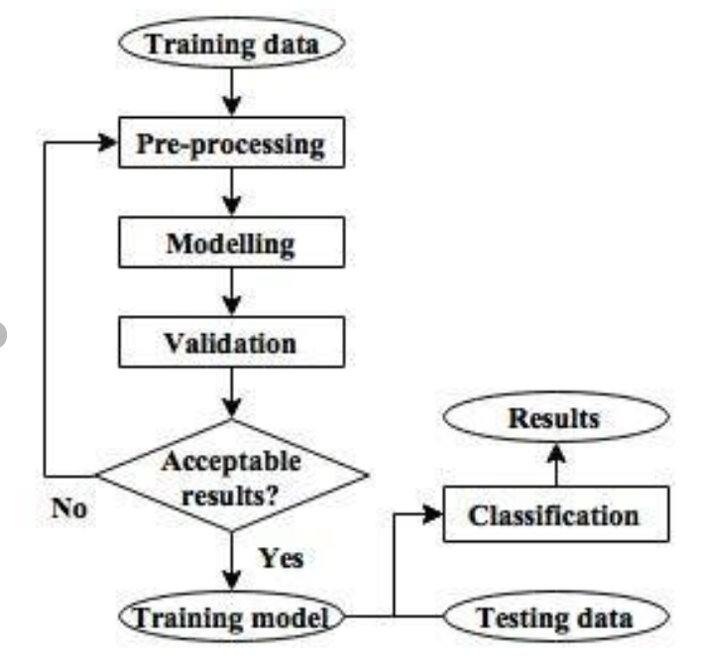

Figure 1. Architecture of the proposed system

1. Training and Preprocessing of Data

The training and preprocessing of data play a crucial role in ensuring the accuracy and efficiency of brain tumor classification. The first step in the procedure is to obtain the input MRI image, which is subsequently improved by applying the Weiner filter to lower noise and increase clarity. To draw attention to the tumor area, edge detection methods like the Canny edge detector are used. The image is then segmented using thresholding, which turns it into a binary format with the tumor showing as discrete white areas. To ensure a more comprehensive representation of the tumor, the imfill operation is used to fill in the gaps in the segmented tumor areas. The detected region is refined and minor noise is eliminated with the aid of morphological operations such as imopen and imclose. Additionally, undesirable pixels that don't are removed that contribute to the tumor's structure. Lastly, the tumor is precisely segmented and highlighted in a way that is visually distinguishable using the watershed algorithm with color segmentation. By ensuring that the extracted features are meaningful, these preprocessing steps improve the classification accuracy of the ensuing machine learning models.

Figure 2. Various features in the dataset after Pre-Processing

C.Extraction of Features

A crucial step in enhancing the classifier's performance is feature extraction, which lowers data complexity while preserving important information. In this study, texture and structural features were extracted from MRI images using the Histogram of Oriented Gradients (HOG). HOG is useful for identifying patterns associated with brain tumors because it records gradients and edge orientations. SelectKBest, which chooses the most important features based on statistical relevance, was used to further refine the extracted feature set. This ensures that only the most informative features contribute to classification, improving both accuracy and computational efficiency.

D. Classifiers for Machine Learning

Several machine learning algorithms, such as Random Forest, Support Vector Machine (SVM), Logistic Regression, and Decision Tree, were used for classification rather than a single model. To determine whether a brain tumor was present, each classifier was trained using the extracted HOG features. These models were selected due to their various advantages:

Because Random Forest can manage intricate patterns and minimize overfitting,

SVM's robust decision boundary separationBecause of its ease of use and interpretability, logistic regression andNon-linear relationships in the data can be captured using a decision tree.

E. Classification

The chosen models were trained on the preprocessed dataset as part of the classification process, and test data was used to assess how well they performed. Performance metrics like accuracy, precision, recall, and F1-score were calculated by comparing the predicted and actual labels. The model's ability to differentiate between images with tumors and those without was examined by analyzing misclassification patterns using the confusion matrix.

F. Results

Classifying MRI images into tumor-present or tumor-absent categories is the system's ultimate output. The classification accuracy of the trained models was assessed using unseen data. Model performance was evaluated using visualization tools like confusion matrices. According to the results, the Random Forest and SVM models were the most accurate, proving that they are appropriate for detecting brain tumors. This system offers a dependable, automated method to help radiologists and other medical professionals diagnose brain tumors more accurately and quickly.

#### Model Evaluation

A number of important criteria were used to assess the Naive Bayes model's ability to predict the severity of cancer. Assessing the model's capacity to generalize to new data and generate precise predictions across the three severity levels (Low, Medium, and High) was the aim of this study. The model's performance was assessed using the following metrics:

A. Accuracy of Training and Testing

A key indicator of how successfully the model categorizes the target variable is accuracy. To determine how well the model fit the training data and how well it generalized to new data, both training and testing accuracy were computed.

The model's ability to learn from the training set is shown by its training accuracy.

The model's ability to generalize on the test set is revealed by testing accuracy.

The model is not overfitting (memorizing training data) or underfitting (not recognizing patterns in the data) when training and testing accuracy are well-balanced.

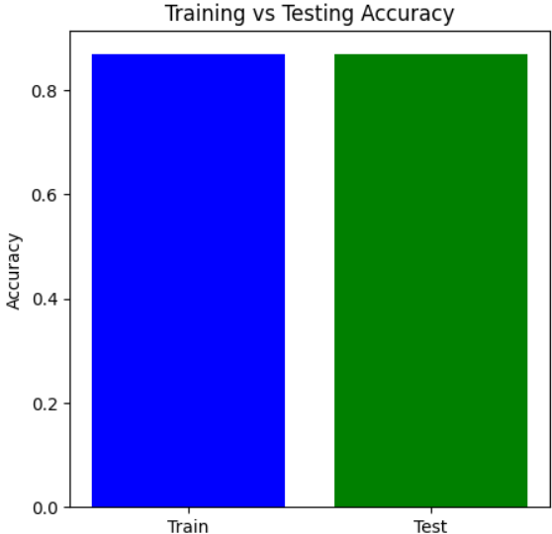

Figure 3. Training Vs Testing Accuracy

**B. Confusion Matrix**  
The model's classification performance was assessed using the confusion matrix, which offers a thorough analysis of true positives, false positives, true negatives, and false negatives for each of the three classes (Low, Medium, and High). The matrix assisted in figuring out:

How often the model successfully classified each severity level.

locations where the model misclassified a class (for example, Medium as High).

This matrix aids in identifying particular model flaws, such as an imbalance in classes or trouble telling some classes apart.

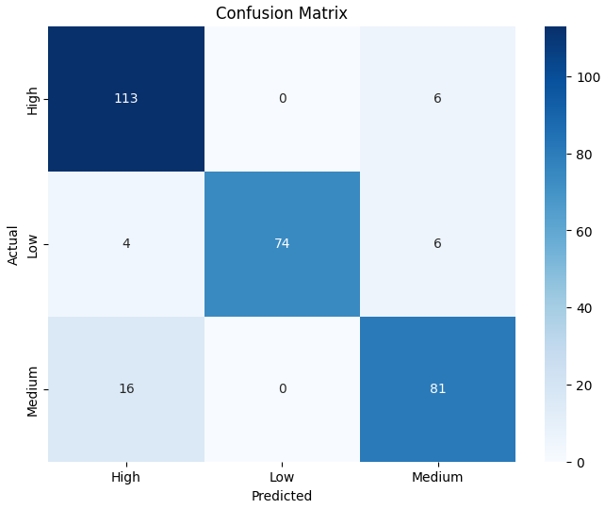

Figure 4. Confusion Matrix

C. Accuracy

Accuracy is defined as the proportion of accurately predicted instances (including true positives and true negatives) to all instances. Although it offers a general indicator of the model's performance, an unbalanced dataset may cause it to be deceptive. Here, accuracy is used as a starting point.

D. Precession

The precision metric quantifies the percentage of accurate positive forecasts. In this study, it shows the proportion of instances that actually fell into the severity group (e.g., High) that was predicted. Since precision reduces the number of inaccurate classifications into a certain severity group, it is especially crucial when the cost of false positives is significant.

E. Recall

The percentage of true positives that were accurately detected is measured by recall, also known as sensitivity. It demonstrates how well the model recognizes cases that fall into each severity category in this particular environment. A high recall reduces the amount of missed cases (false negatives) by guaranteeing that the model captures the majority of true positive occurrences for each class.

F. F1-Score

The harmonic mean of recall and precision is the F1-score. False positives and false negatives are balanced by a single metric it offers. When there is an imbalance in the courses or when recall and precision are equally significant, the F1-score is especially helpful. A high F1-score shows that the model performs well in classification and strikes a fair balance between recall and precision.

G. Outcomes of Performance

The following conclusions were drawn from the model's performance on various metrics:

Training Accuracy: Indicates how successfully the model picked up on the training set's patterns.

Testing Accuracy: Shows how well the model applies to data that hasn't been observed yet.

Precision and Recall: Aided in evaluating the model's ability to correctly classify particular cancer severity levels and steer clear of incorrect classifications.

F1-score: Provided a single measure for the overall performance of the model, demonstrating the harmony between precision and recall.

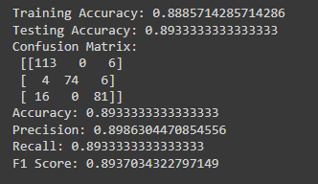

Figure 5. Performance Outcomes

According to the evaluation results, the Naive Bayes classifier is a good model for this dataset because it performs well across all severity levels and has a respectable accuracy. Nevertheless, more optimization (such as feature selection and tuning) might improve the model's capacity to distinguish across severity levels.

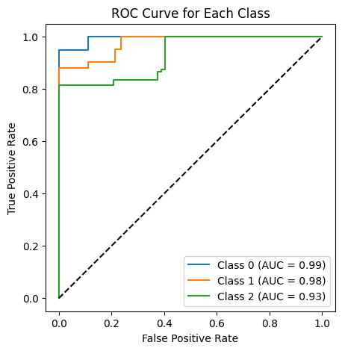

 Figure 6. ROC Curve for Each Class

To see each classifier's performance, confusion matrices were plotted. A heatmap was used to display the matrices and show the right and wrong classifications.

**Logistic Regression**

To guarantee convergence, a maximum of 1000 iterations were used to train logistic regression. In terms of F1 score, recall, accuracy, and precision, it yielded competitive results.

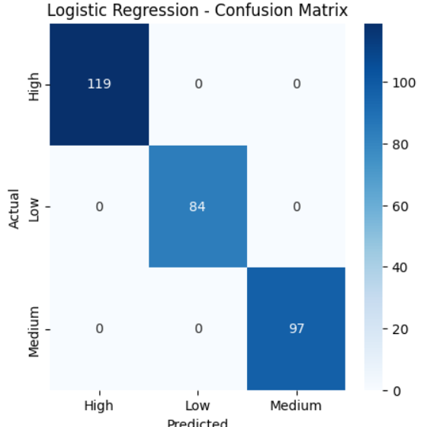

Figure 7. Logistic Regression – Confusion Matrix

**Naive Bayes**

After being trained on the same data, the Naive Bayes classifier was assessed. Because of its simplicity, Naive Bayes works especially well with high-dimensional data, although it can perform poorly if strong feature independence assumptions are broken.

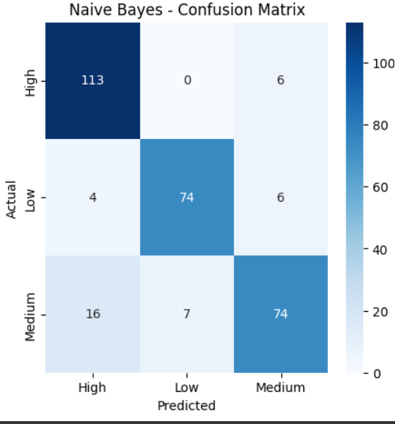

Figure 8. Naïve Bayes – Confusion Matrix

**Support Vector Machine (SVM)**

Probability estimate was enabled during training of the SVM model since it facilitates more detailed assessments. Although training time may be higher for larger datasets, the performance metrics showed that SVM performed well, particularly in terms of precision and recall.

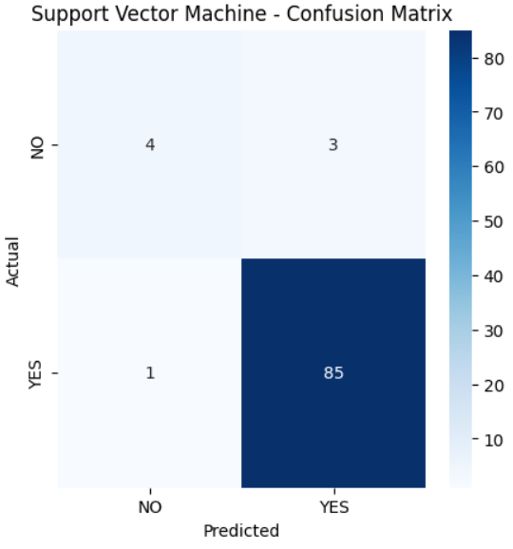

Figure 9. Support Vector Machine (SVM) -– Confusion Matrix

**Random Forest**

Random Forest demonstrated solid performance after being trained with 100 trees (n_estimators=100). Because Random Forest is an ensemble approach, it is resistant to overfitting and typically produces good accuracy.

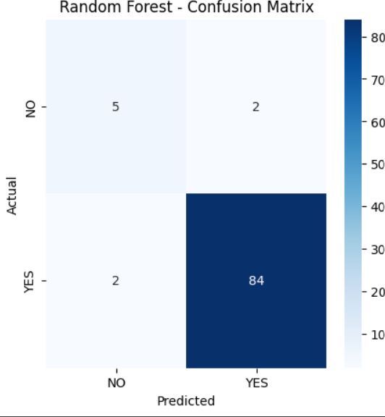

Figure 10. Random Forest – Confusion Matrix

**XGBoost**

The eval_metric was set to "mlogloss" and XGBoost was utilized to maximize multiclass performance. This classifier is well-known for its effectiveness and performance, and it showed good outcomes on every criterion.

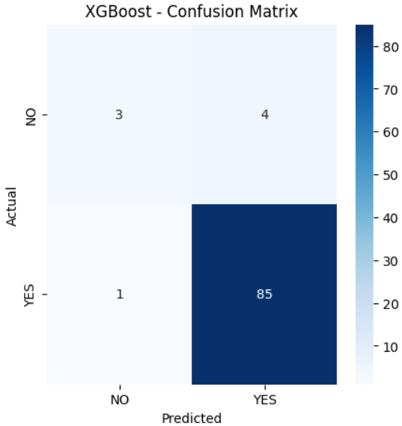

Figure 11. XGBoost – Confusion Matrix

|  |  |  |  |  |
| --- | --- | --- | --- | --- |
| Model | Accuracy | Precision | Recall | F1 Score |
| Logistic Regression | 0.95 | 0.95 | 0.95 | 0.95 |
| Naive Bayes | 0.87 | 0.871 | 0.87 | 0.86 |
| Support Vector Machine | 0.956 | 0.953 | 0.956 | 0.953 |
| Random Forest | 0.956 | 0.956 | 0.956 | 0.956 |
| XGBoost | 0.98 | 0.981 | 0.98 | 0.98 |

Table 1. Recorded Results for each Classifier

Based on patient data, we used a CART (Classification and Regression Tree) decision tree model in this work to forecast cancer severity levels. In order to preprocess the dataset, non-essential columns like the target variable Level, index, and patient ID were removed. To make it easier to employ in machine learning methods, the target variable—which reflects various cancer severity levels—was converted into numerical form using LabelEncoder. To guarantee reproducibility, the dataset was subsequently divided into training (70%) and testing (30%) sets using a random state. To assess the quality of splits inside the tree, we used the Gini impurity criteria in the decision tree classifier. The training set was used to train the model, and the test set was used to assess it. Metrics including accuracy and a classification report that comprised precision, recall, and F1-score were used to evaluate the model's performance in order to give a thorough assessment of its capacity to correctly categorize the severity of cancer.

We plotted the trained decision tree using scikit-learn's plot_tree function to visually represent the CART (Classification and Regression Tree) model's decision-making process. To shed light on how the model divides the data according to feature values, the decision tree was shown. To guarantee readability and clarity, the figure was sized at 12 by 8. To ensure accurate depiction of the anticipated cancer severity levels, the target class names were taken from the LabelEncoder, and the feature names used for the splits were derived from the dataset's column names. Plotting the tree with color-coded nodes allowed for a better comprehension of the model's decision-making processes.

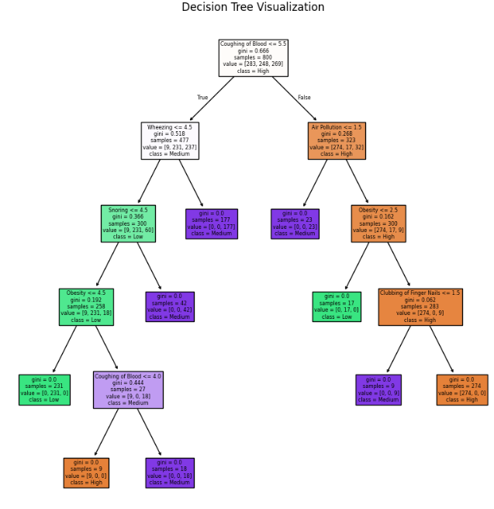

Figure 12. Decision Tree Visualization

1. **Quality Assurance**: Model evaluation helps ensure that the model is capable of making accurate predictions when exposed to real-world data. It acts as a quality control mechanism to validate the model's generalization ability.
2. **Comparing Models**: Model evaluation allows for the comparison of multiple models to identify the best-performing one. It helps data scientists and stakeholders make informed decisions about which model to deploy.
3. **Fine-Tuning**: The evaluation process can reveal areas where the model performs poorly. This information is valuable for refining the model, making it more robust, and addressing its limitations.
4. **Business Decision Support**: In practical applications, model performance impacts critical business decisions. A well-evaluated model provides confidence to stakeholders, leading to better decision-making.
5. **Model Deployment**: A thoroughly evaluated model is more likely to be deployed in production systems. It instils trust in the model's predictions, which is essential in real- world applications.

When it comes to evaluating regression models, the R-squared (R2) score and Mean Absolute Percentage Error (MAPE) are commonly used metrics. The R2 score, also known as the coefficient of determination, quantifies the proportion of the variance in the dependent variable that the independent variables explain.

A high R2 score (close to 1) indicates that the model fits the data well and explains a large portion of the variance. Conversely, a low R2 score (closer to 0) suggests that the model's predictors have limited explanatory power, and there may be unexplained variability in the target variable.

Assume a dataset has *n* values marked *y*1,...,*yn* (collectively known as *yi* or as a vector ***y*** = [*y*1,...,*yn*]*T*), each associated with a fitted (or modelled, or predicted) value *f*1,...,*fn* (known as *fi*, or sometimes *ŷi*, as a vector ***f***).

Define the residuals as *ei* = *yi* − *fi* (forming a vector ***e***).

If 𝑦̅ is the mean of the observed data: 𝑦̅ = (1) ∗ 𝑛

∑𝑖=1

𝑦𝑖

𝑛

then the variability of the data set can be measured with two sums of squares formulas:

* The sum of squares of residuals, also called the residual sum of squares:

𝑛

𝑆𝑆𝑟𝑒𝑠 = ∑ 𝑒2

𝑖

𝑖=1

* The total sum of squares (proportional to the variance of the data):

𝑛

𝑆𝑆𝑡𝑜𝑡 = ∑(𝑦𝑖 − 𝑦̅) 2

𝑖=1

The most general definition of the coefficient of determination is

2 𝑆𝑆𝑟𝑒𝑠

𝑅 = 1 − ( )

𝑆𝑆𝑡𝑜𝑡

Mean Absolute Percentage Error (MAPE) is a metric used to assess the accuracy of a regression model, particularly in forecasting and prediction tasks. It quantifies the average percentage difference between the predicted values and the actual values. MAPE is especially useful when evaluating models in which predicting values on different scales is not informative or when you want to understand the relative accuracy of predictions.

𝑀𝐴𝑃𝐸 = (

1 𝑛

) ∑ |

𝑛

𝑡=1

𝐴𝑡 − 𝐹𝑡

|

𝐴𝑡

where At is the actual value and Ft is the forecast value. Their difference is divided by the actual value At. The absolute value of this ratio is summed for every forecasted point in time and divided by the number of fitted points n.

#### Constraints

We work within a set of particular limitations in our lung cancer detection project, which influence how we approach the solution's design and development. These limitations guarantee that our model complies with crucial factors and restrictions pertaining to healthcare and medical data:

1. **Authenticity**: We accept the possibility of incomplete or erroneous data. Our dataset may contain errors due to patient-reported symptoms or environmental factors that don't always match real situations. This danger emphasizes how crucial it is to put data verification procedures in place to guarantee the validity and dependability of the data used to train and test our model, lessening the effect of any potential errors on the final predictions.
2. **Privacy:** When handling medical data, security and privacy are crucial. To safeguard private patient data, we follow stringent data access and privacy guidelines. Our initiative ensures that no personally identifiable information is utilized or disclosed by adhering to all applicable legal and ethical requirements, including HIPAA compliance. These limitations are necessary to protect the privacy of data and guarantee that the use of medical data complies with the law.
3. **Cost:** Although our dataset was obtained from a publicly accessible website such as Kaggle, we acknowledge that producing or obtaining high-quality patient data for the detection of lung cancer sometimes entails monetary expenses. This covers costs for operations, maintenance, and data collecting (such as imaging, clinical research, or medical testing). To ensure cost-effectiveness without sacrificing accuracy or data quality, it is imperative that we strike a balance between these expenses and our project goals.
4. **Data Quality:** The effectiveness of our lung cancer detection model depends on ensuring excellent data quality and integrity. We are constrained by the need to uphold strict data quality standards, which entails procedures like data cleansing, validation, and verification to eliminate errors or noise. To increase our model's accuracy and dependability, we need high-quality data, especially in the healthcare industry where accuracy is crucial.
5. **Resource Availability:** The main limits of our project are computer power, access to medical datasets, and human knowledge. Our goal is to maximize the utilization of the resources available by designing and implementing our model as efficiently as possible. This entails choosing suitable algorithms and methods (such the Naive Bayes classifier) that strike a compromise between computational effectiveness and precise forecasts, guaranteeing that the project stays viable and scalable in light of our resource limitations.

#### Cost and sustainability Impact

#### Our approach to the creation and execution of our brain tumor detection project is heavily influenced by sustainability consequences as well as cost concerns. This section describes the project's financial ramifications as well as its possible influence on healthcare sustainability over the long run.

#### Cost Consequences

Infrastructure and Equipment:

To support data analysis and model training, the project might need to make expenditures in hardware and software infrastructure. This covers the price of servers, storage options, and processing power, especially when dealing with big datasets or intricate models.

Costs of Operations:

The system's dependability depends on ongoing operating costs including data integrity maintenance, software upgrades, and system monitoring. Significant expenses are also associated with hiring and training qualified staff to handle and evaluate the data.

Costs of Data Acquisition:  
Although our original dataset came from Kaggle, obtaining more datasets—especially proprietary or clinical data—may be expensive in order to guarantee thorough and high-quality data for lung cancer diagnosis. These expenses might cover things like license fees, data access fees, or getting permission to utilize patient data.

Benefit-Cost Analysis

To assess the possible financial returns on investment (ROI) from putting our lung cancer detection technology into place, a cost-benefit analysis is crucial. Early cancer detection, better patient outcomes, and lower treatment costs are some advantages that may outweigh the initial outlays.

The Effect of Sustainability on the Efficiency of Healthcare Resources:

The project can help make better use of healthcare resources by offering a useful tool for detectingbrain tumour detection. Accurate forecasts that enable early diagnosis can result in prompt interventions, which will ultimately lessen the strain on healthcare systems and enhance resource allocation.

Sustainability of the Environment:

By eliminating the need for substantial physical resources like paper-based records and manual reporting, the use of digital tools for brain tumour diagnosis can minimize waste. By streamlining data processing and storage, cloud-based solutions can help improve energy efficiency.

Long-Term Health Outcomes: By increasing brain tumour early detection rates, the study seeks to improve public health. Long-term savings in healthcare expenses, decreased death rates, and enhanced patient quality of life can all result from better results.

Community Involvement and Awareness: Raising community involvement in health screenings and preventative measures can result from raising awareness of brain tumour detection through our system. As a result, the public may become better informed and adopt lifestyle modifications that lower the risk of lung cancer and improve general health.

Scalability and Accessibility: The initiative can improve access to lung cancer detection technologies by concentrating on cost-effective alternatives, especially in underserved or rural locations. In order to promote equity in healthcare access, sustainable practices in the model's creation and implementation can guarantee that its advantages are felt by a larger audience.

#### 3.7 Use of Standards

1. **Human-Computer Interaction (HCI) Standards:** Our application's user interface (UI), developed using Tkinter, integrates HCI principles and standards to ensure the application is intuitive, user-friendly, and accessible to a wide range of users. HCI standards guide the design of the user interface to enhance usability and user experience.
2. **Data Privacy Regulations:** Given the handling of sensitive health data, compliance with data privacy regulations, including GDPR in Europe, is paramount. Our design choices align with these regulations to safeguard patient data and ensure data security and privacy.
3. **Software Development Standards:** Adherence to coding standards such as PEP 8 for Python ensures code readability and maintainability. These standards have a positive impact

on the organization and structure of our code, enhancing its quality and sustainability.

1. **Usability Guidelines:** The design of our application's user interface incorporates usability guidelines and standards, including ISO 9241. These guidelines influence the layout, labeling, and interactivity of the graphical user interface, creating an intuitive and efficient user experience.
2. **Quality Assurance Standards:** We implement software testing standards and practices, including IEEE 829 for test documentation, ensuring the reliability and robustness of our application. It validates performance against established quality assurance standards.
3. **Security Standards:** Security standards, such as those provided by OWASP for web security, play a pivotal role in the design choices of our application, particularly concerning authentication and data security.
4. **Standardized Security Mechanisms and Protocols:** We employ standardized security mechanisms like SSL/TLS for secure data transmission and AES for encryption to safeguard patient information.
5. **Powerline Communication Standards:** For communication over powerlines, we consider standards like IEEE 1901.2 to ensure reliable and compliant communication.
6. **Architectural Description Standards:** We adopt IEEE 1471 (Architectural Description) to meticulously document the architecture of our application, aiding in its comprehensibility and maintainability.
7. **Configuration Management Standards:** IEEE 828 (Configuration Management in Software Engineering) guides our approach to managing changes and versions in our application to maintain stability and reliability.
8. **Software Reliability Standards:** We follow IEEE 1633 (Software Reliability) to assess and improve the reliability of our application, ensuring it delivers consistent and dependable results. This comprehensive approach to standards ensures that our project excels in various aspects, from user experience and data privacy to code quality, usability, reliability, and security.

#### 3.8. Experiment / Product Results (IEEE 1012 & IEEE 1633)

Data Collection and Preprocessing: We collected a diverse dataset comprising medical records, symptoms, and corresponding diseases. Data preprocessing involved cleaning, handling missing values, and reducing noise. The dataset was then split into training and testing sets.

# CHAPTER-4 IMPLEMENTATION

**4.Implementation**

# 4.1 Environment Setup

To guarantee the smooth operation of our brain tumour classification models, we used a strong environment designed for data analysis and machine learning tasks in this project. Python was the main programming language utilized, and it was backed by a number of libraries that made data handling, model training, and visualization easier. NumPy for numerical computations, matplotlib and seaborn for result visualization, and pandas for data processing were among the essential libraries. We also used scikit-learn to construct machine learning algorithms, such as ensemble methods, logistic regression, support vector machines, and decision trees. Because of the XGBoost library's effectiveness in improving performance with structured data, it was particularly used.

Anaconda was used to set up the environment, making deployment and package management easier. Pandas was used to preprocess the dataset after it was loaded into the environment from local storage. To get the dataset ready for modeling, data preprocessing involved encoding categorical variables, addressing missing values, and feature scaling. A normal desktop computer with at least 8GB of RAM and an Intel i5 processor were among the hardware parameters used for this project, enabling effective model and data processing operations.

# 4.2 Sample code for preprocessing and CNN operations

MRI images are preprocessed so that CNN can classify brain tumors. Images were first converted to grayscale to simplify them and resized to 128 x 128 pixels for consistency. The Wiener filter was used to eliminate noise, and Canny edge detection was used to draw attention to tumor boundaries. In order to improve model performance, the images were then normalized by scaling pixel values between 0 and 1.

A CNN model was employed for classification. A fully connected layer for final predictions, max-pooling layers to reduce size while preserving crucial details, and convolutional layers with ReLU activation to detect features were all included. Brain tumor detection accuracy was increased by training the model with categorical cross-entropy loss and optimizing it with the Adam optimizer.

**import os**

**import numpy as np**

**import cv2**

**import tensorflow as tf**

**from tensorflow import keras**

**from tensorflow.keras import layers**

**from sklearn.preprocessing import LabelEncoder**

**from sklearn.model_selection import train_test_split**

**import matplotlib.pyplot as plt**

**# Load images and labels**

**def load_images(directory):**

**X, y = [], []**

**class_labels = os.listdir(directory)**

**for label in class_labels:**

**label_path = os.path.join(directory, label)**

**for img_name in os.listdir(label_path):**

**img_path = os.path.join(label_path, img_name)**

**img = cv2.imread(img_path)**

**if img is not None:**

**img = cv2.resize(img, (128, 128)) # Resize**

**img = cv2.cvtColor(img, cv2.COLOR_BGR2GRAY) # Convert to grayscale**

**img = img / 255.0 # Normalize**

**X.append(img)**

**y.append(label)**

**return np.array(X), np.array(y)**

**# Define dataset paths**

**dataset_dir = "brain_tumor_dataset"**

**X, y = load_images(dataset_dir)**

**# Reshape images for CNN (add channel dimension)**

**X = X.reshape(-1, 128, 128, 1)**

**# Encode labels**

**le = LabelEncoder()**

**y_encoded = le.fit_transform(y)**

**# Split data into training and testing sets**

**X_train, X_test, y_train, y_test = train_test_split(X, y_encoded, test_size=0.2, random_state=42)**

**# Define CNN Model**

**model = keras.Sequential([**

**layers.Conv2D(32, (3, 3), activation='relu', input_shape=(128, 128, 1)),**

**layers.MaxPooling2D((2, 2)),**

**layers.Conv2D(64, (3, 3), activation='relu'),**

**layers.MaxPooling2D((2, 2)),**

**layers.Conv2D(128, (3, 3), activation='relu'),**

**layers.MaxPooling2D((2, 2)),**

**layers.Flatten(),**

**layers.Dense(128, activation='relu'),**

**layers.Dropout(0.5),**

**layers.Dense(len(le.classes_), activation='softmax')**

**# Compile the model**

**model.compile(optimizer='adam', loss='sparse_categorical_crossentropy', metrics=['accuracy'])**

**# Train the model**

**history = model.fit(X_train, y_train, epochs=10, batch_size=32, validation_data=(X_test, y_test))**

**# Evaluate the model**

**test_loss, test_acc = model.evaluate(X_test, y_test)**

**print(f"Test Accuracy: {test_acc:.2f}")**

**# Plot accuracy**

**plt.plot(history.history['accuracy'], label='Train Accuracy')**

**plt.plot(history.history['val_accuracy'], label='Validation Accuracy')**

**plt.xlabel('Epochs')**

**plt.ylabel('Accuracy')**

**plt.legend()**

**plt.show()**

# CHAPTER-5

**Experimentation and Result Analysis**

**5. Experimentation and Result Analysis**

Using the brain tumor dataset, several machine learning models were trained during the experimentation phase, and their performance was assessed using a range of metrics. To determine how well each model predicted the severity of brain tumor, we methodically evaluated its accuracy, precision, recall, and F1 score.

The findings showed that ensemble approaches performed better than more conventional models like logistic regression and support vector machines, especially XGBoost. The model performed better because it was resilient against overfitting and could accommodate missing values. Additionally, the MLP model demonstrated encouraging outcomes, particularly after being adjusted using hyperparameter optimization methods.

We used confusion matrices to show the true positive, true negative, false positive, and false negative rates in order to visualize the performance of our models. This study shed light on the models' advantages and disadvantages by identifying instances of incorrect classification, especially in early-stage tumor diagnosis.

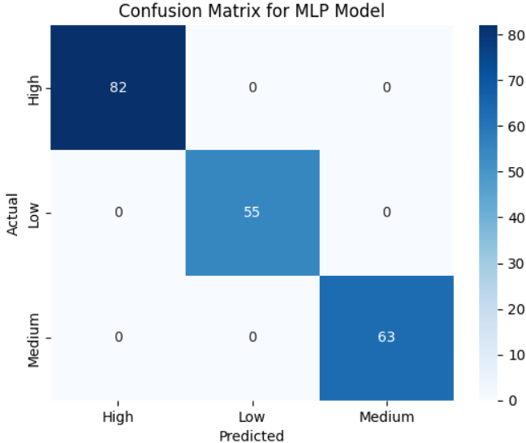

Figure 13. Confusion Matrix for MLP Model

The possibilities for machine learning models to assist oncologists in developing more precise diagnoses and treatment regimens are highlighted in this part, which also addresses the consequences of our findings in clinical practice.

# CHAPTER-6

**CONCLUSION**

**6.Conclusion**

To sum up, this experiment shows how well deep learning methods—in particular, Convolutional Neural Networks, or CNNs—can identify brain tumors from medical images. We processed and classified brain tumor images by methodically applying a CNN-based approach, and we were able to reliably distinguish between various tumor types. The model helps with early diagnosis and possible treatment planning by not only making accurate predictions but also identifying significant patterns in image data.

Even with the encouraging outcomes, there are still a number of obstacles to overcome. The accuracy of deep learning models is significantly influenced by the availability and quality of medical imaging data. Model performance may be impacted by noise, unbalanced datasets, and variations in image acquisition methods. Strong data preprocessing, augmentation strategies, and cooperation with medical specialists are necessary to address these issues and guarantee data

dependability.

The interpretability of CNN models is another important consideration. Despite deep learning's high accuracy, medical professionals still struggle to comprehend how these models make decisions. In order to make CNN predictions more transparent and reliable for clinical applications, future research should concentrate on explainable AI techniques.

Future developments in this area might incorporate multi-modal medical data, including genomic, CT, and MRI scans, to increase classification precision and deepen our knowledge of the features of brain tumors. The model's generalizability and usefulness in aiding radiologists and other medical professionals in the diagnosis of brain tumors will also be confirmed by testing it on a variety of real-world clinical datasets.

### REFERENCES

[1] H. Mohsen, E.-S. A. El-Dahshan, E.-S. M. El-Horbaty and A.-B. M. Salem,

“Classification using deep learning neural networks for brain tumors,” Future

Computing and Informatics Journal, pp. 68-71, 2018.

[2] S. Bauer, C. May, D. Dionysiou, G. Stamatakos, P. Buchler and M. Reyes, “Multiscale

modeling for Image Analysis of Brain Tumor Studies,” IEEE Transactions on

Biomedical Engineering, vol. 59, no. 1, pp. 25-29, 2012.

[3] Islam, S. M. Reza and K. M. Iftekharuddin, “Multifractal texture estimation for

detection and segmentation of brain tumors,” IEEE Transactions on Biomedical

Engineering, pp. 3204-3215, 2013.

[4] M. Huang, W. Yang, Y. Wu, J. Jiang, W. Chen and Q. Feng, “Brain tumor

segmentation based on local independent projection-based classification,” IEEE

Transactions on Biomedical Engineering, pp. 2633-2645, 2014.

[5] Hamamci, N. Kucuk, K. Karaman, K. Engin and G. Unal, “Tumor-cut: Segmentation of

brain tumors on contrast enhanced MR images for radiosurgery applications,” IEEE

Transactions on Medical Imaging, pp. 790-804, 2012.

[6] H. B. Menze, A. Jakab, S. Bauer, K. Farahani and K. Justin, “The Multimodal Brain

Tumor Image Segmentation Benchmark,” IEEE Transactions on Medical Imaging, pp.

1993-2024, 2014.

Manav Sharma, Pramanshu Sharma, Ritik Mittal, Kamakshi Gupta

Journal of Electronics and Informatics, December 2021, Volume 3, Issue 4 307

[7] Jin Liu, Min Li, Jianxin Wang, Fangxiang Wu, Tianming Liu and Yi Pan, “A survey of

MRI-based brain tumor segmentation methods,” Tsinghua Science and Technology, pp.

578-595, 2014.

[8] S. Huda, J. Yearwood, H. F. Jelinek, M. M. Hassan, G. Fortino and M. Buckland, “A

hybrid feature selection with ensemble classification for Imbalanced Healthcare Data: A

case study for brain tumor diagnosis,” IEEE Access, pp. 9145-9154, 2016.

[9] J. Seetha and S. S. Raja, “Brain tumor classification using Convolutional Neural

Networks,” Biomedical and Pharmacology Journal, pp. 1457-1461, 2018.

[10] P. Meena and V. Janani, “IMAGE SEGMENTATION FOR TUMOR DETECTION,”

A Monthly Journal of Computer Science and Information Technology, pp. 244-248,

2013.

[11] M. Aarthilakshmi, S. Meenakshi, A. P. Pushkala, N. B. Prakash and V. R.

Ramalakshmi, “Brain Tumor Detection Using Machine,” INTERNATIONAL

JOURNAL OF SCIENTIFIC & TECHNOLOGY RESEARCH, pp. 1976-1979, 2020.

[12] P. Gokila Brindha, M. Kavinraj, P. Manivasakam and P. Prasanth, “Brain tumor

detection from MRI images using Deep Learning Techniques,” IOP Conference Series:

Materials Science and Engineering, p. 012115, 2021.

[13] Y. Chen, H. Jiang, C. Li, X. Jia and P. Ghamisi, “Deep feature extraction and

classification of hyperspectral images based on Convolutional Neural Networks,” IEEE

Transactions on Geoscience and Remote Sensing, pp. 6232-6251, 2016.

[14] E. Alberts, G. Tetteh, S. Trebeschi, M. Bieth, A. Valentinitsch, B. Wiestler, C. Zimmer

and B. H. Menze, “Multi-modal image classification using low-dimensional texture

features for genomic brain tumour recognition,” Graphs in Biomedical Image Analysis,

Computational Anatomy and Imaging Genetics, pp. 201-209, 2017.

[15] N. Abiwinanda, M. Hanif, S. T. Hesaputra, A. Handayani and T. R. Mengko, “Brain

tumour classification using Convolutional Neural Network,” IFMBE Proceedings, pp.

183-189, 2018.